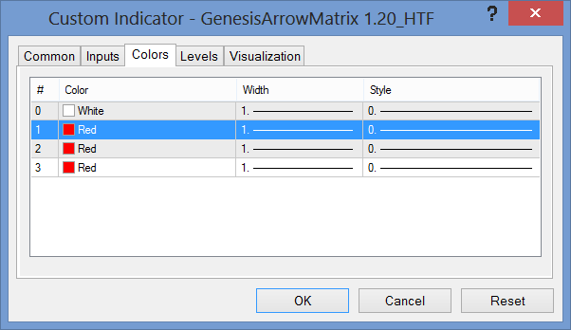
How do I get the WIDTH to 0 (Zero)??

